﻿Analysis Worksheet Lab 1

1. **Include photos of your papers showing all the lines and measurements you made, along with your TAs signature. Note: If the quality of the photo is poor, you may not receive full marks.**

[Please Go To Next Page]

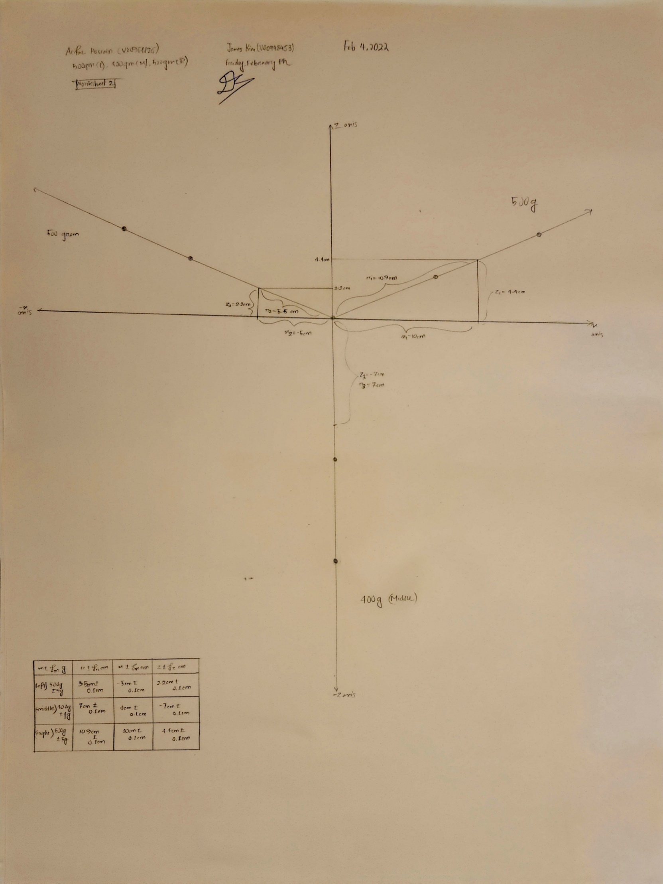

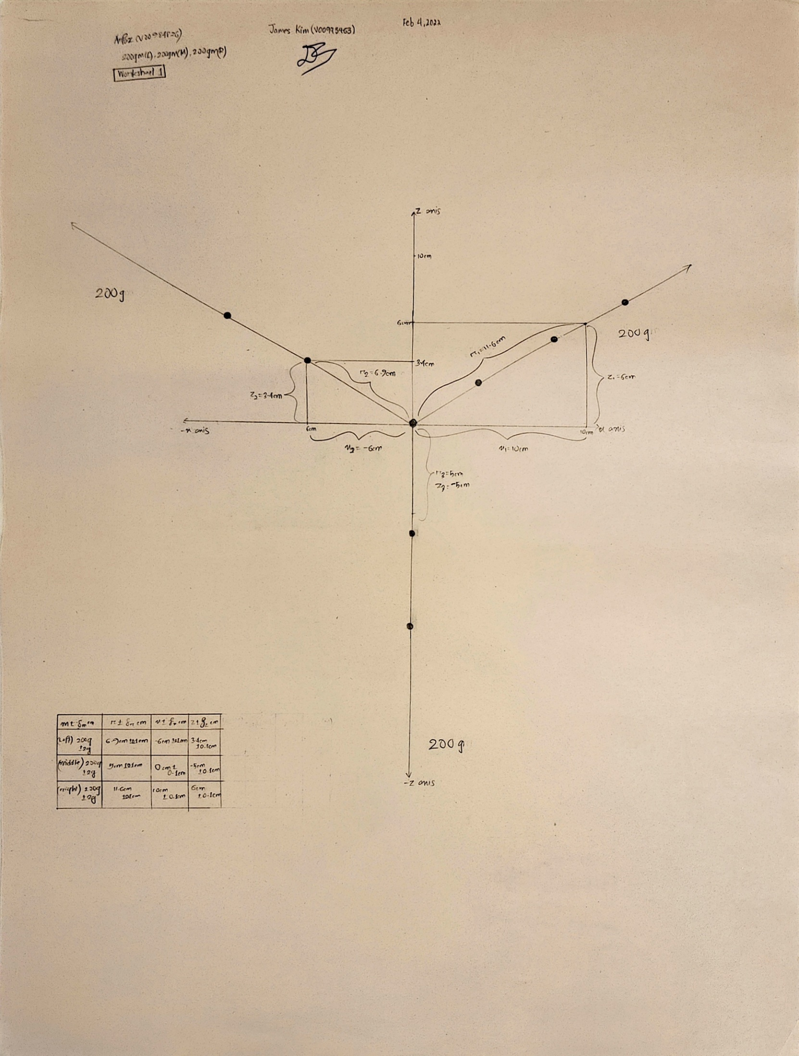

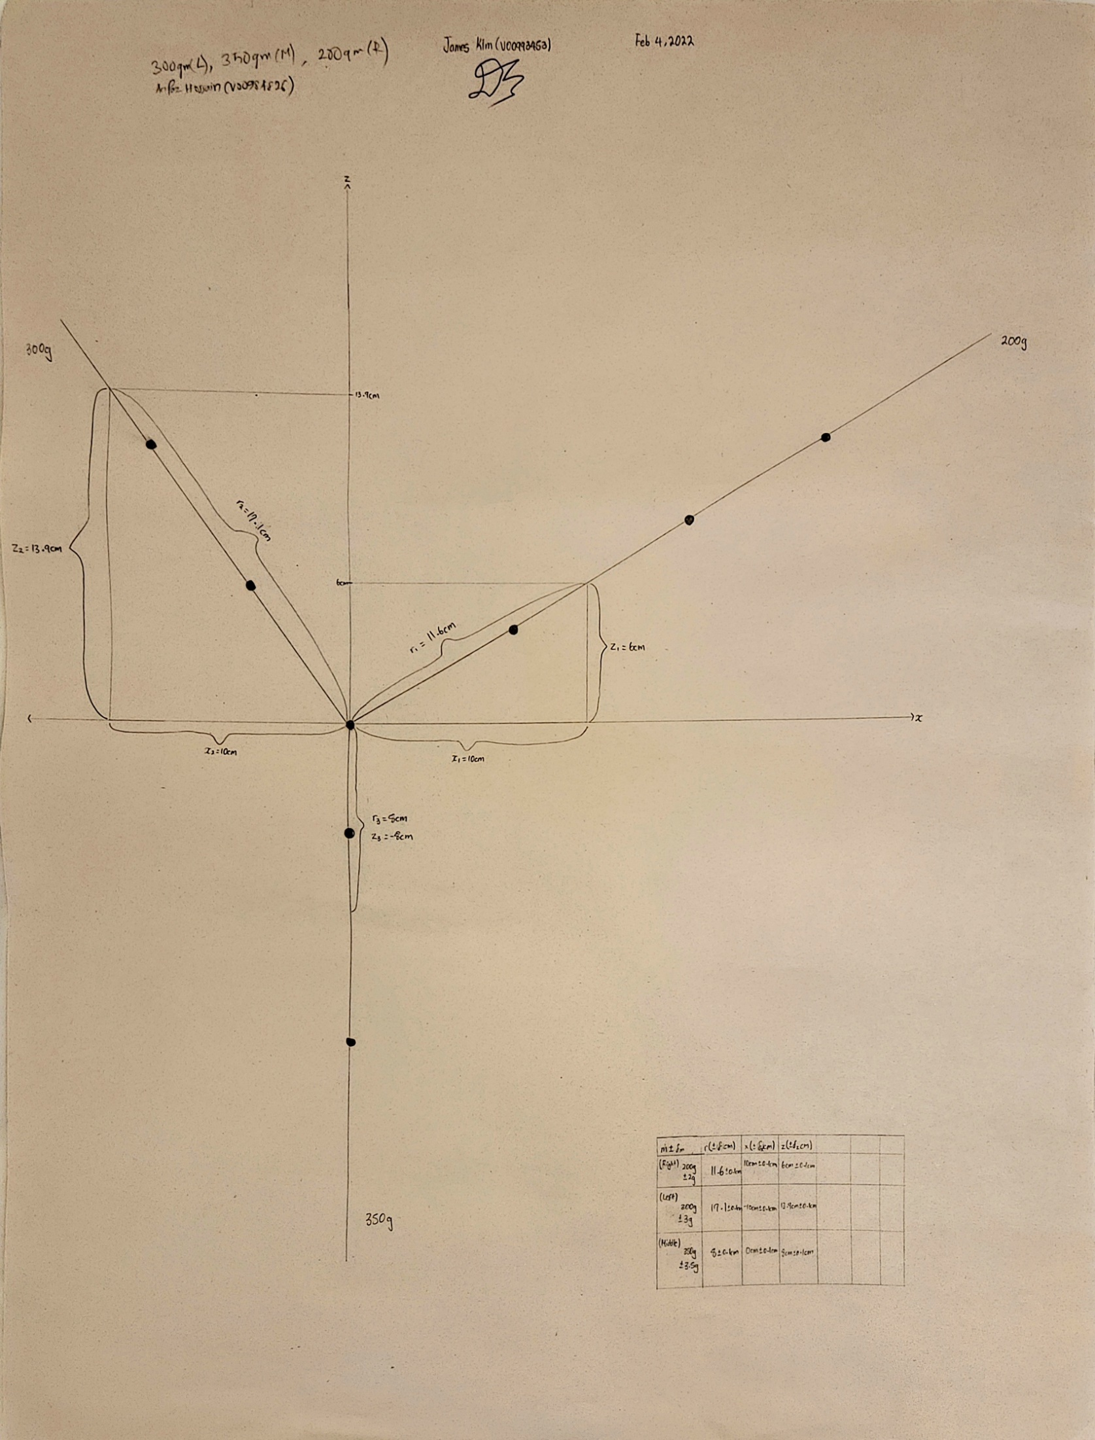

1. **Show all of formulas you used for determining each individual Fx and Fz from your measurements, along with the formulas for uncertainties. These formulas will be the ones you use in your spreadsheet to fill out your table of values.**

[Please Go To Next Page]

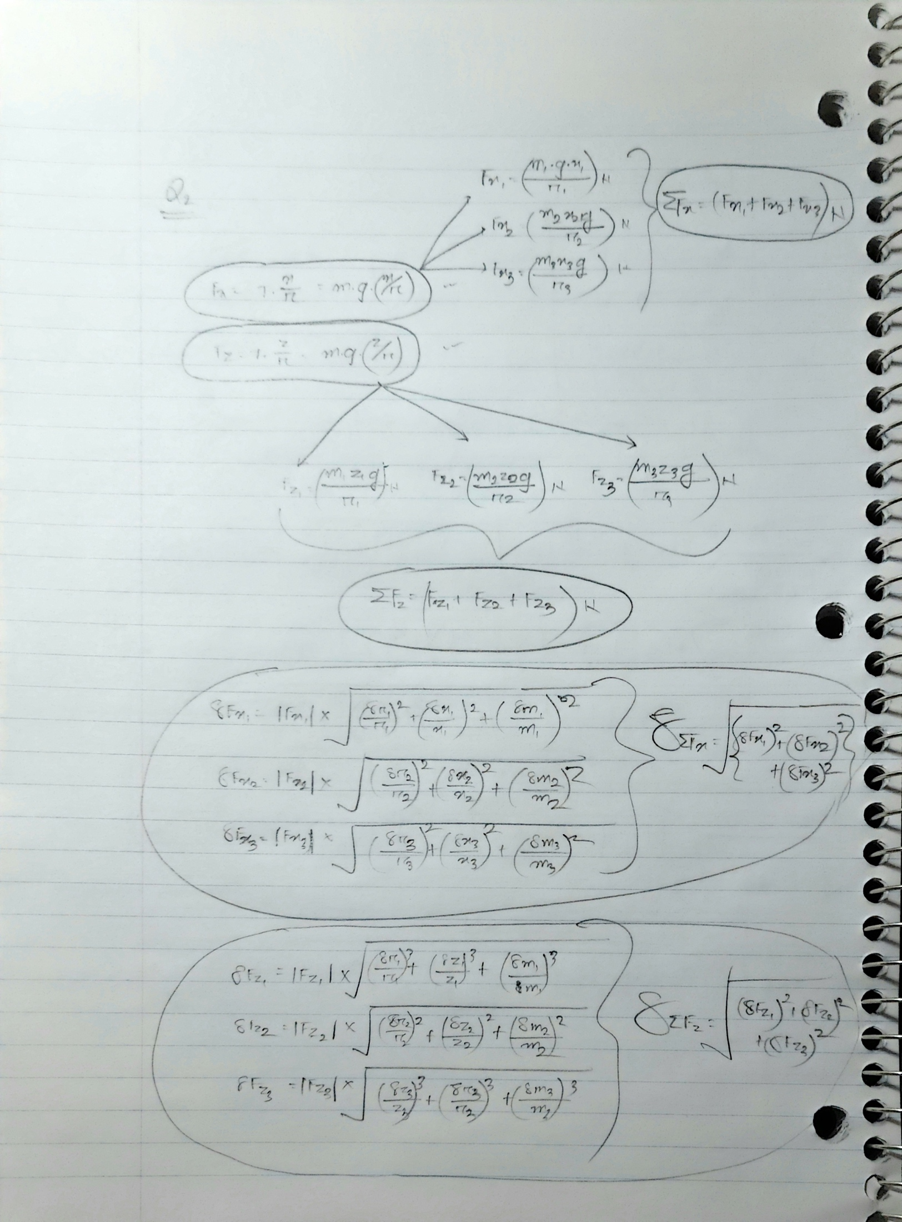

1. **Summarize your results in a table with columns for labeling the mass system and force, the x component of the force and its uncertainty, and the z component of the force and its uncertainty. (See the description in the Analysis and Writeup section.)**



**(Same Picture, just tabled)**

#



**4. Show all your calculations in summing the forces and determining the uncertainty in the sum of forces for each direction and for each combination of masses. (Do not do this in your spreadsheet.)**

[Please Go To Next Page]

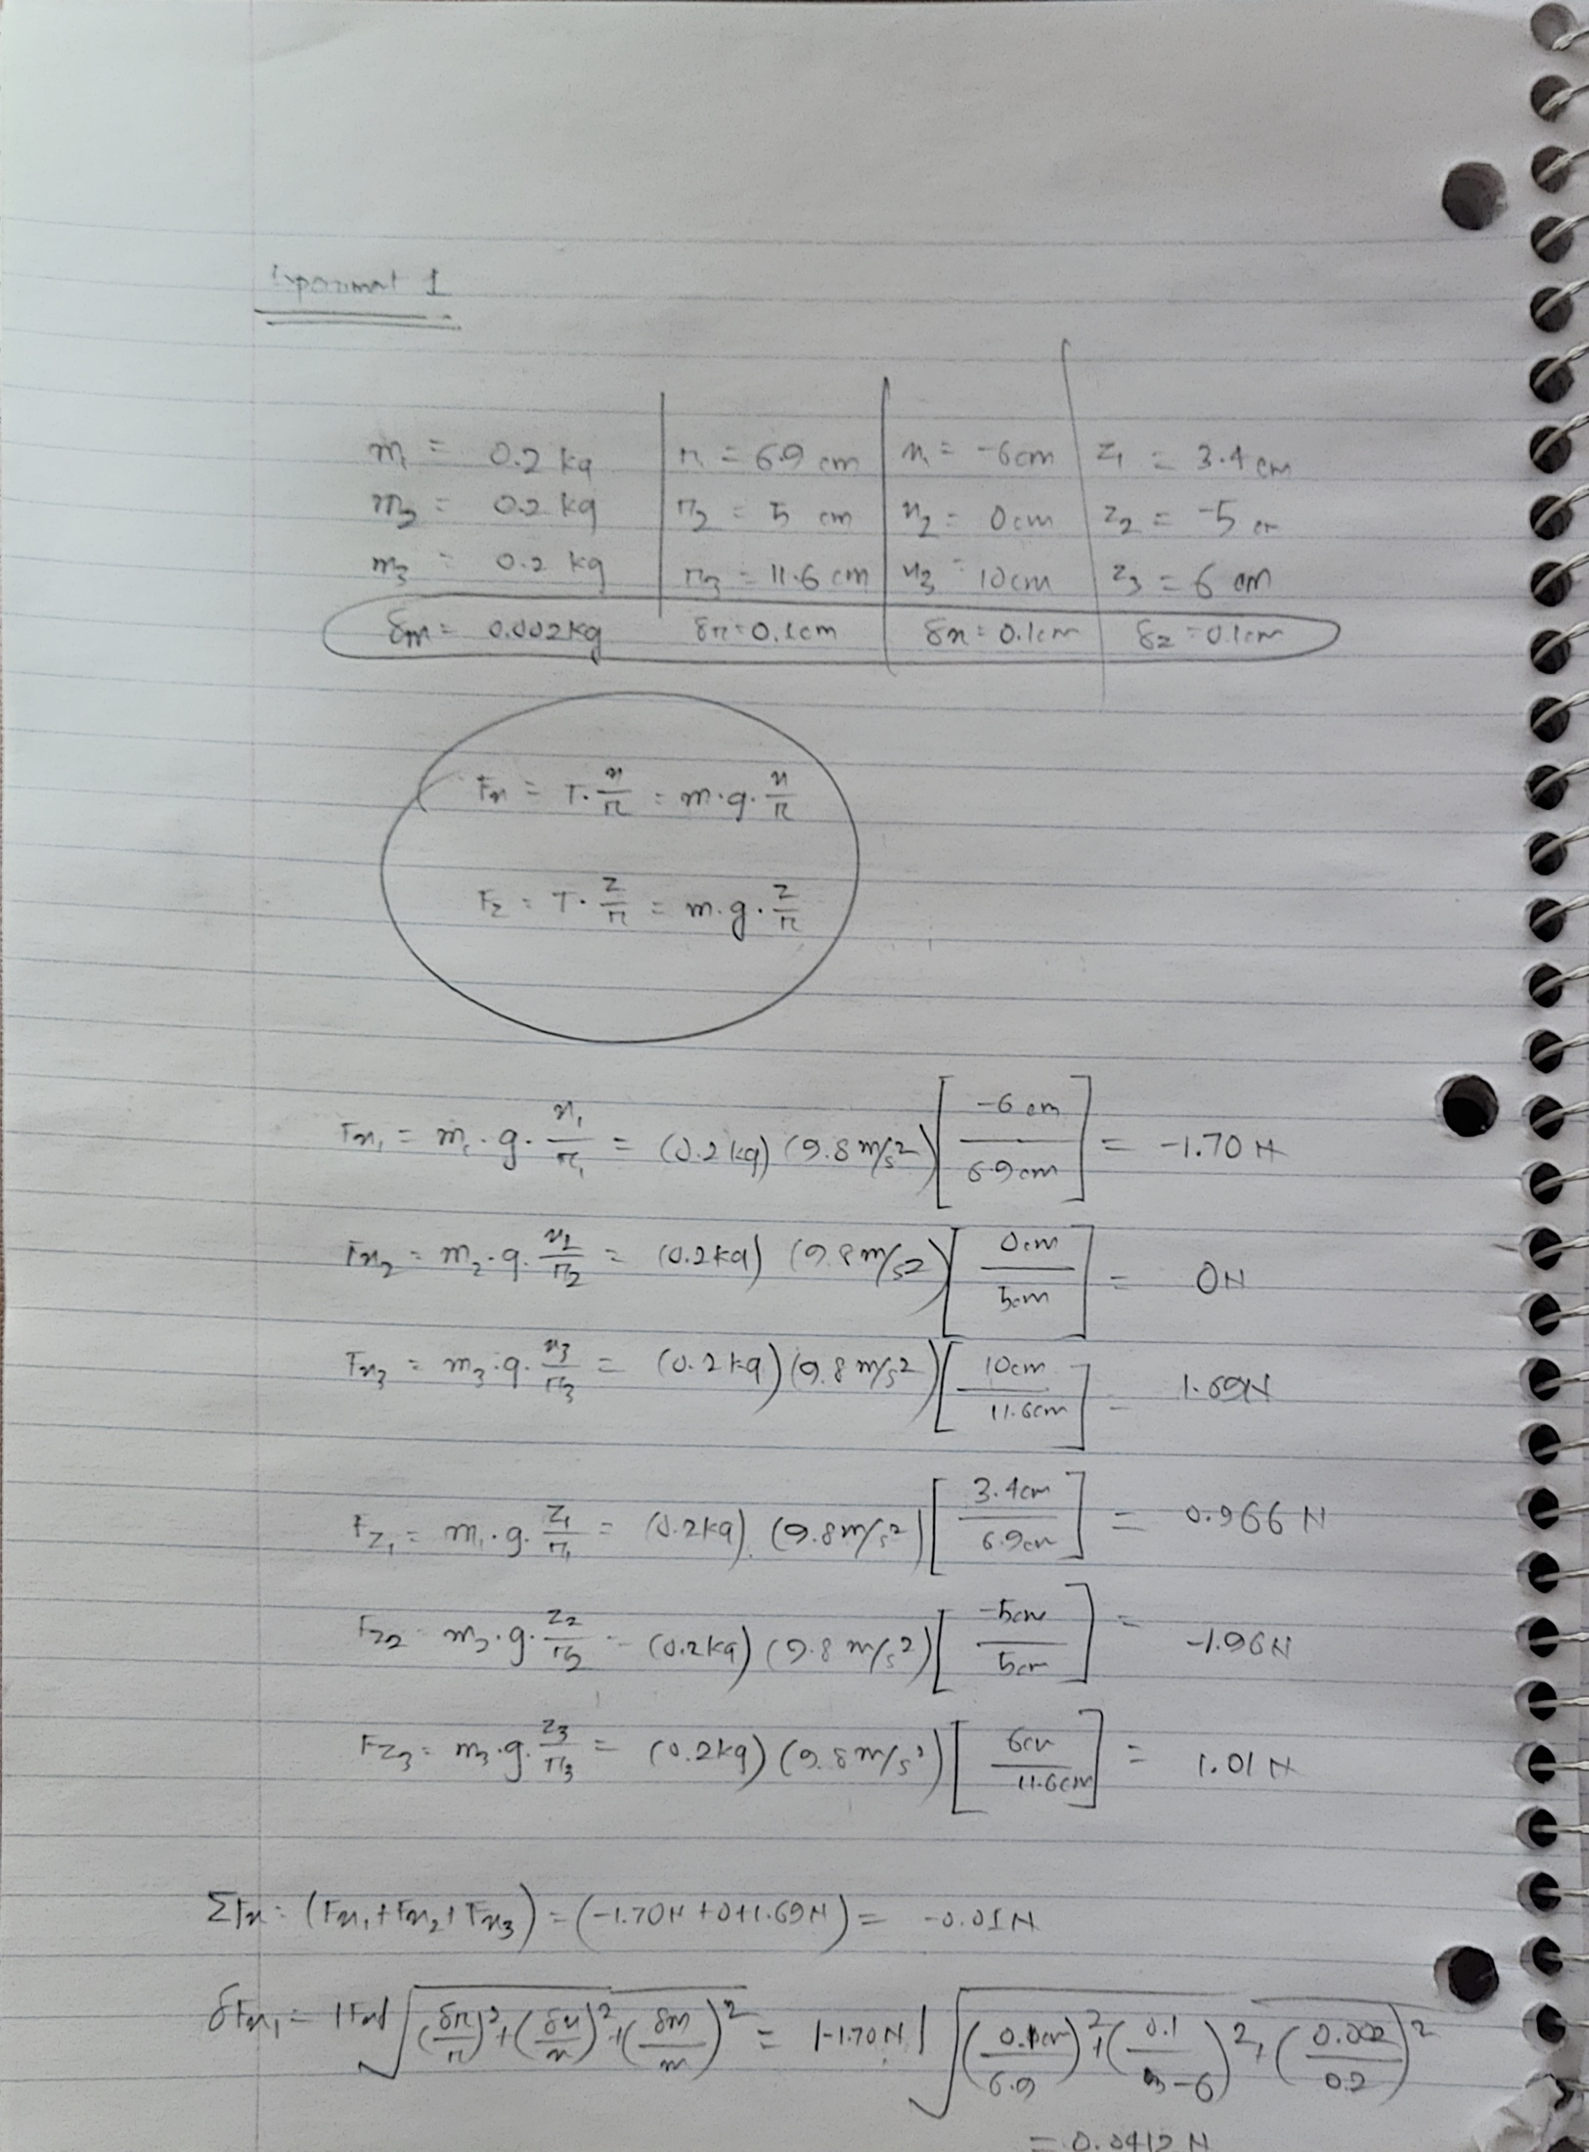

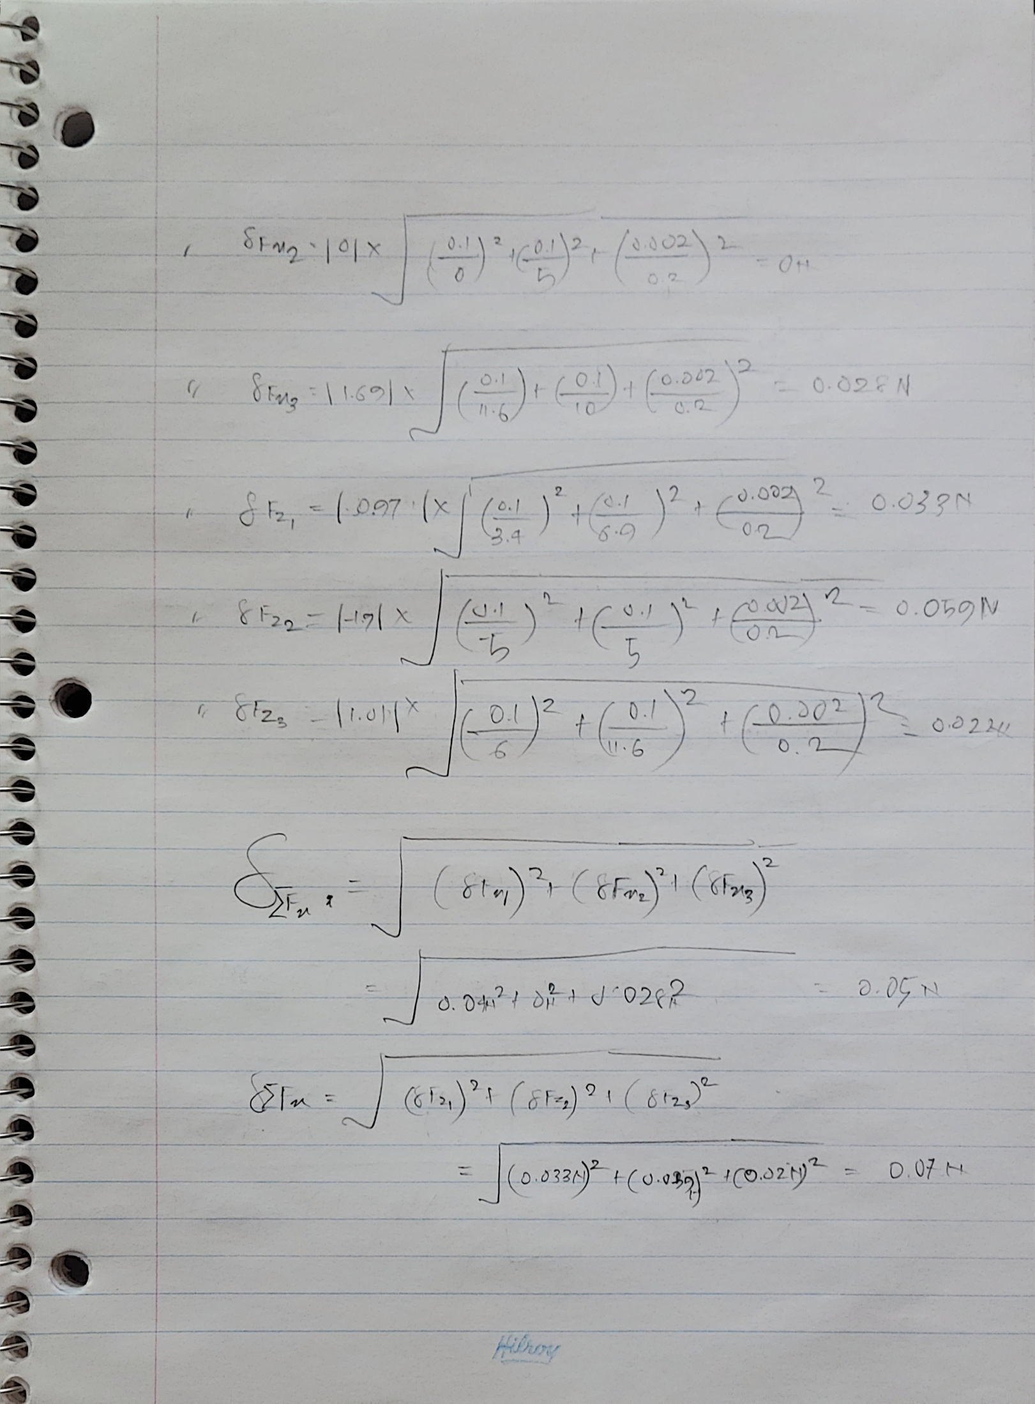

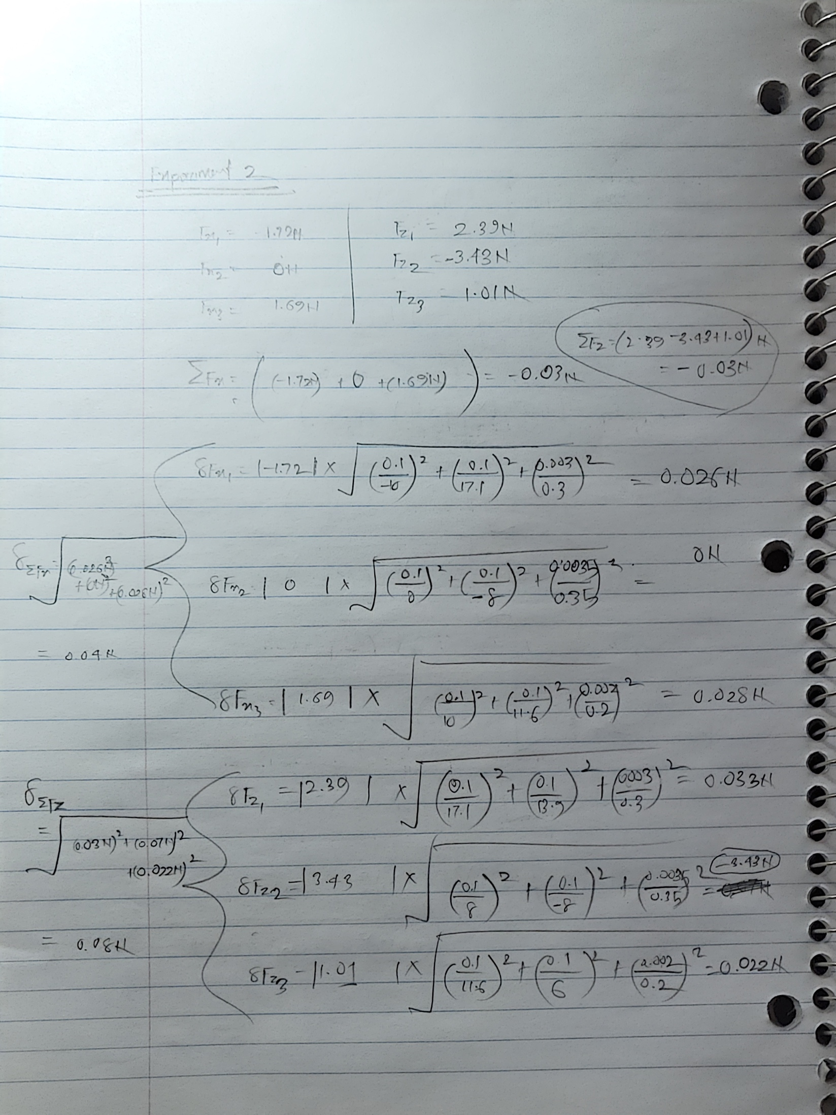

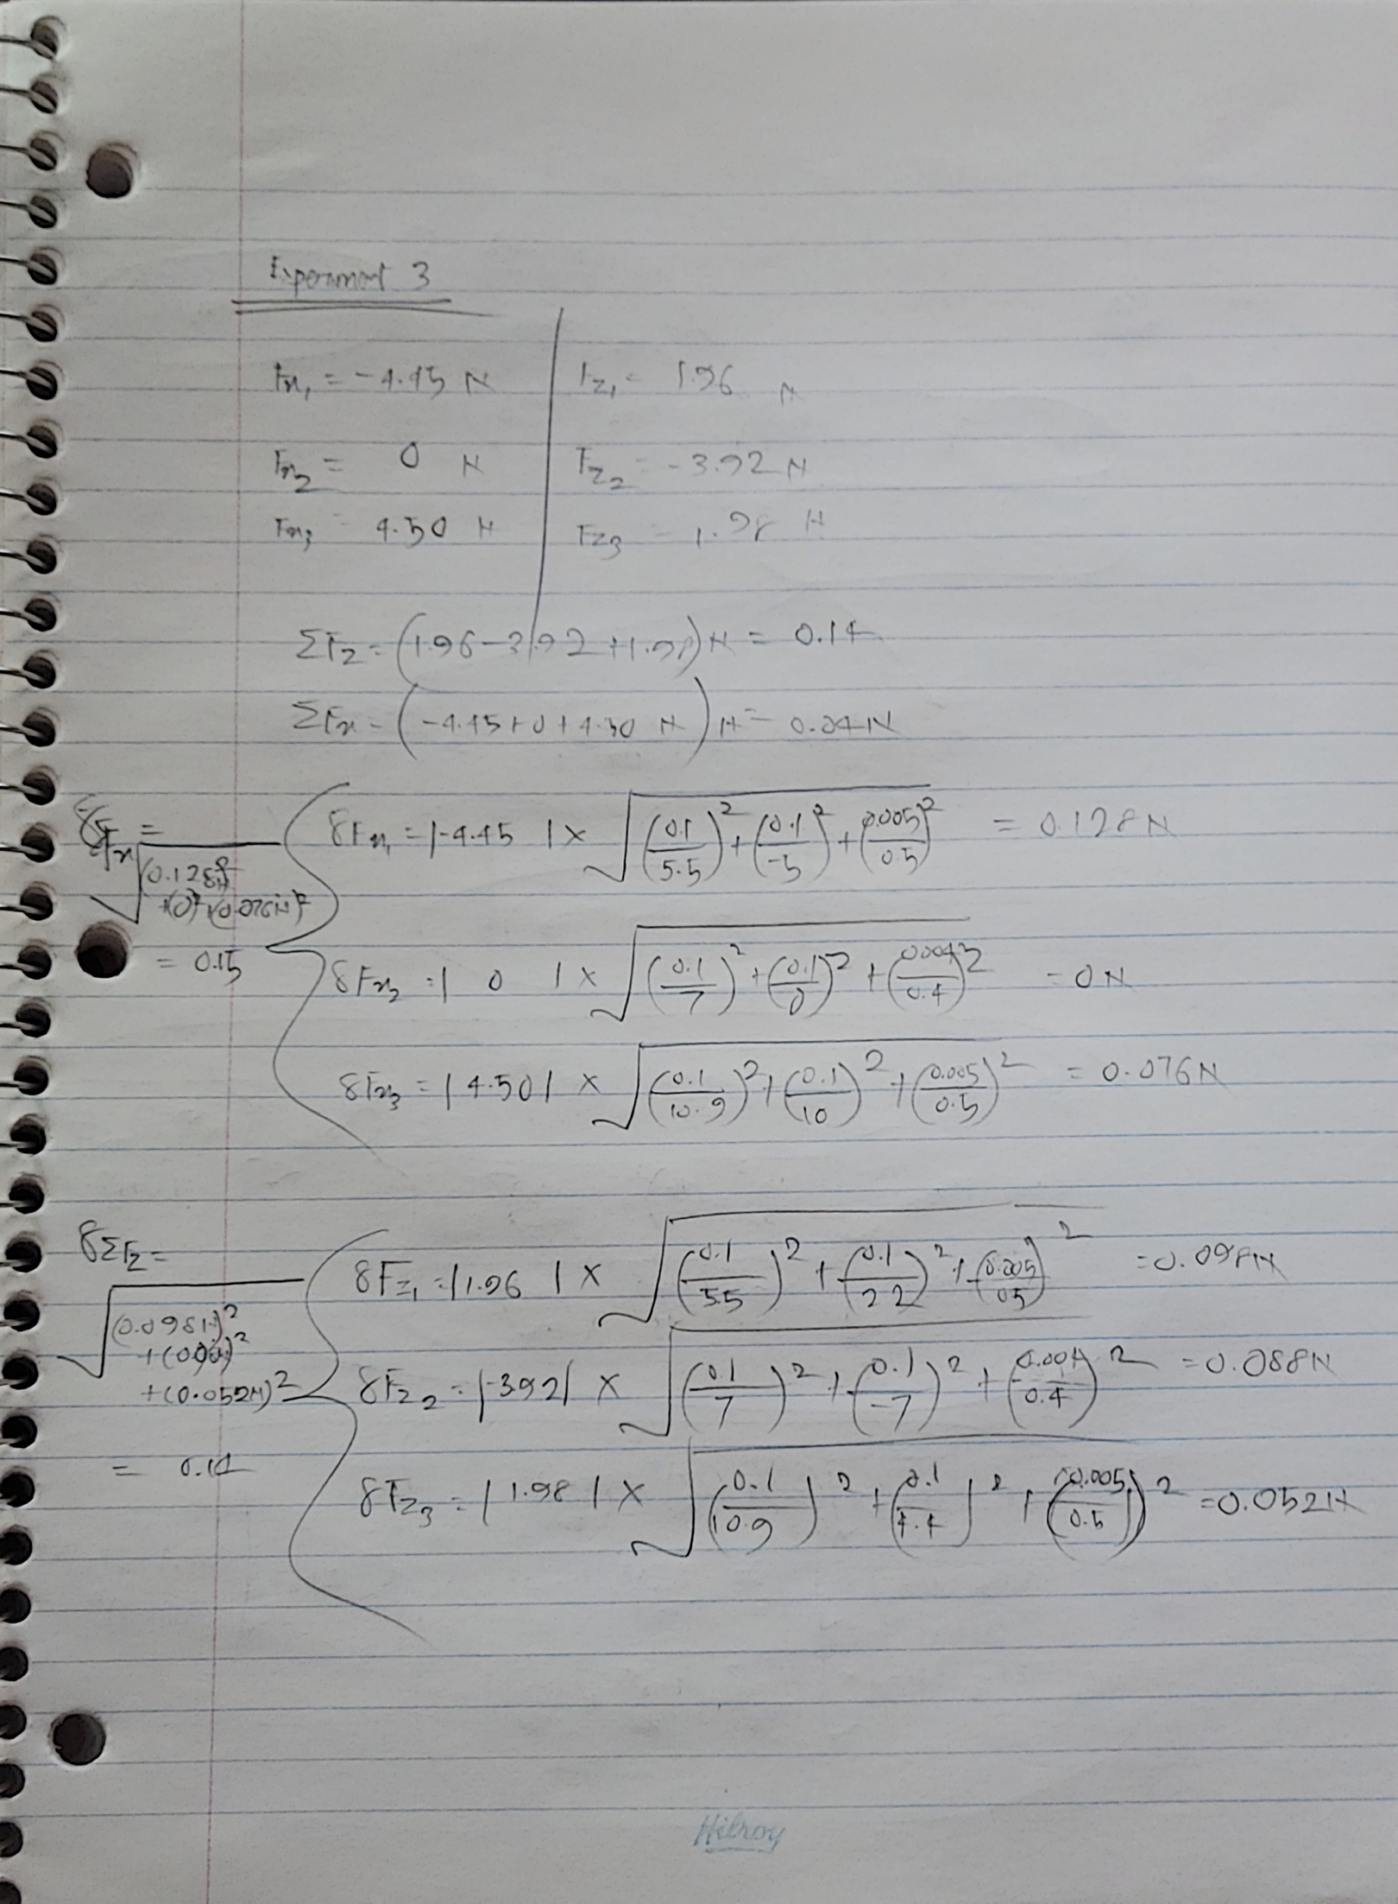

1. **Explicitly state the expected value for the sum of forces in the x and z directions. Perform a statistical comparison of each sum of forces, as compared to the appropriate theoretical/expected value.**

[Please Go To Next Page]

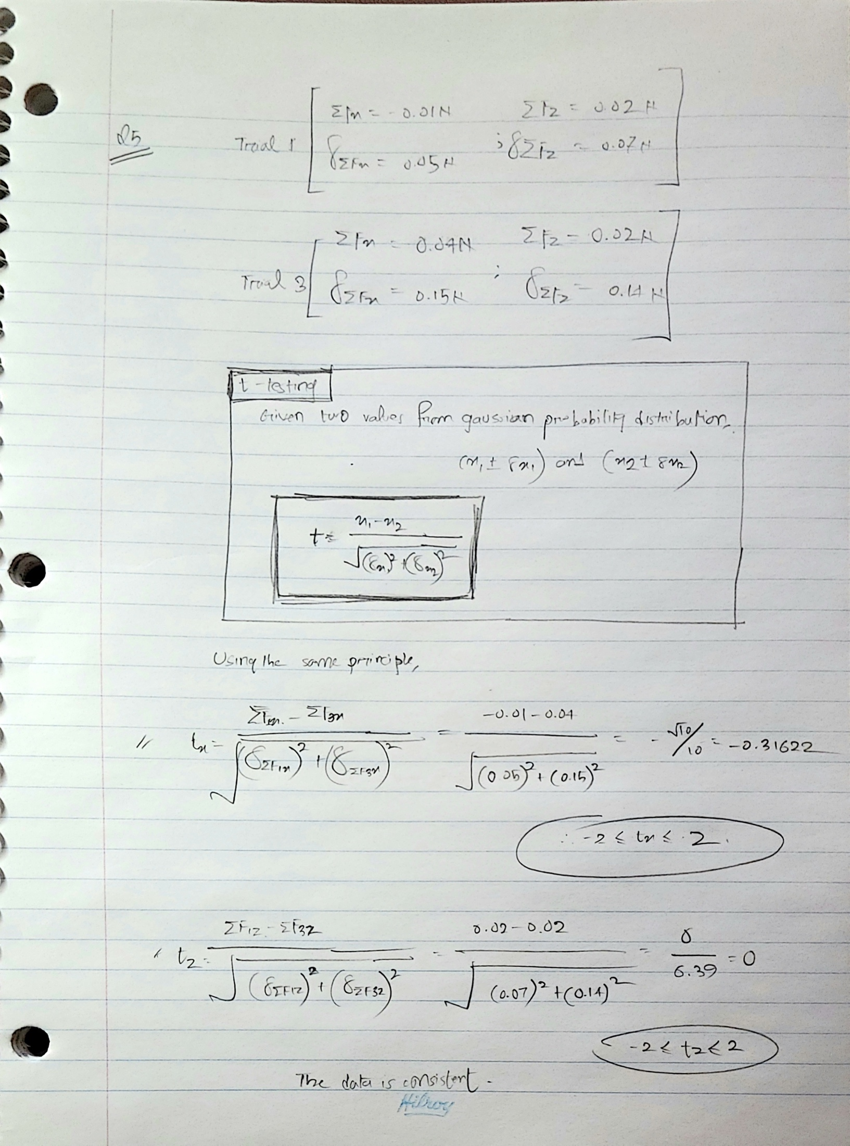

**6. Respond to the following questions/instructions using complete sentences:**

(a) Why are three points used instead of two points for each branch of the force diagrams?

In each of the branches of the Force Diagram, we used three points to create a line. If we had taken two points and forced them to meet, it wouldn’t have given an accurate representation of the line, while taking the readings from the strings. Taking three points helped us to ensure that even if one of the points was out of focus, or a little away from the actual position of the string, through minimizing the deviation created from the other two points, we can have a much closer representation of the line from the readings of the string.

(b) Why would putting all three points close together and making your Y shapes small be a bad idea for this experiment?

For a close-to-accurate representation of our string, we need to ensure that we are taking the readings of the set of data that we have, and we are properly using the data to make a precise line of our force diagram. Taking all three points close to each other means smaller difference between data points, which can either give us an accurate representation of our line or can also give us a larger uncertainty value from our data points. Larger uncertainty values give a lower accurate representation of our line due to low precision. However, taking points with larger difference between them can help us find a closer deviated line through plotting the points, which, though might not give us either too-accurate or too-inaccurate result, but it will give us a value which is in the acceptable range of a consistent experiment (-3 ≤ t ≤ 3?).

(c) What does it mean if your statistical comparison is larger or smaller than 2? Why is a value of 2 used?

In our pairwise t-test, we are using only two of the correlated samples for comparing the average mean value between the two values. A value of t, larger or smaller than 2 generally means that the difference between those values is more than what it should have been statistically for comparing two values, in short – deviation in the results is larger than it should’ve been (hence, worse accuracy). Therefore, the value ±2 is used in a pairwise t-test to determine whether an experiment concerning two values is giving us consistent results in accurate measurement. (± is referring to whether the data deviated to the upper or lower bound, hence inconsistent in our consideration).

(d) What is the largest component of the uncertainty in determining Fx and Fz?

The largest component of uncertainty (higher deviated value of a data set) has been the set of values from Fz, as results from the sum of the uncertainty in all individual masses in three trials shows a slightly larger deviated value of Fz, in compared to Fx. The largest uncertainty in Fx is 0.15*N* and for Fz, 0.14*N*.

(e) How can you independently verify that your lines for determining the x and z components are square? Use this to test several of your lines and show your works.

To determine whether the x and z components, when added together, gives us square.

For checking to see whether our measurement is consistent with the help of Pythagoras’s theorem:

$r^{2}=x^{2}+z^{2}$**⇔ $r=\sqrt{x^{2}+z^{2}}$** , we are using pythogorus as z axis and z axis are perpendicular and we can use this to get an almost accurate measurement of r. But we also know that $d^{2}=x^{2}+z^{2}$ is the formula for finding the diameter of a rectangle. For a rectangle to be a square, both sides must be the same size,

x = z, which can also mean, $r^{2}=x^{2}+z^{2}$**⇔ $x=\sqrt{r^{2}-z^{2}}$** or, $z=\sqrt{r^{2}-x^{2}}$**.** This means, for each value of x and z, there is a value of r, which is squared.

Trial 1 Mass 1 $\sqrt{{(-6m)}^{2}+{(3.4m)}^{2}}=6.8m$ ≈ 6.9*m*

Trial 2 Mass 2 $\sqrt{{\left(0m\right)}^{2}+{\left(-8m\right)}^{2}}=8m$ ≈ 8.1*m*

Trial 3 Mass 3 $\sqrt{{(10m)}^{2}+{(4.4m)}^{2}}=10.8m$ ≈ 10.9*m*